# Sensory feedback

## Sensory feedback control of locomotor pattern generation in cats and mice :

2 types of proprioceptive signals:

1. Group Ia and II afferent fibers, Ia => dynamic (angular joint movement), II => static (angular joint position)
2. Group Ib afferents carrying information from GTOs, sensitive to force, sensory regulation of muscle activity

GTOs : Golgi tendon organs, at myotendinous junction

Cutaneous feedback, minor changes if suppressed, but important for stability and when inclined/declined walking or walking on horizontal ladder

Proprioceptive feedback controls :

1. Strength of muscle activation
2. Transitions from stance to swing phases

2 proprioceptive signals :

1. Muscle spindles : hip joint needs to extend to a specific position that is signalled by muscle spindles from the hip flexor muscles to start a swing phase
2. GTOs : loading of extensor muscles signalled by GTOs => prevents the initiation of the swing phase. It’s been suggested that unloading of the extensor muscles during the progression of the stance phase is a necessary sensory signal that contributes to the transition from stance to swing phase

Locomotor pattern can be achieved by the CPGs in the absence of sensory feedback BUT UNSTABLE

The CPG would only generate a flexor-extensor alternation where all flexor and extensor motoneuron pools would be active during the flexor or extensor phases, respectively

* Sensory feedback necessary to achieve the actual pattern that occurs during intact locomotion

Major cutaneous feedback changes in spinal cats (ex. dI3 interneurons responsible for cutaneous reflex responses) in locomotion when no sensory feedback

Sensory feedback shown in stumbling reaction => activation of flexor muscles to pull the leg higher when obstacle touching during swing, but not during stance phase (stumbling corrective reaction)

Removal of proprioceptive feedback (GTOs + muscles spindles feedbacks) => major effects on locomotor pattern = ataxia

## Six-legged walking in insects: how CPGs, peripheral feedback, and descending signals generate coordinated and adaptive motor rhythms :

EVIDENCE for CPGs existence :

*Such networks were termed central pattern generators (CPG), because they are capable of generating rhythmic motor output in the absence of phasic or rhythmic input*

*In summary, the stick insect data suggest that there exist at least three individual CPGs governing the three main leg joints, i.e., the thorax-coxa joint, the coxa-trochanter joint, and the femurtibia joint*

*It was first in the cockroach that Pearson and Fourtner (1975) identified a local nonspiking interneuron (interneuron I) in the metathoracic ganglion, which they proposed as a candidate CPG neuron. This interneuron showed membrane potential oscillations in synchrony with leg movements. Furthermore, small depolarizing or hyperpolarizing current injections in this interneuron caused changes in firing rates [...] small depolarizing current injections into the interneuron during particular phases of the motor neuron firing cycle could reset the rhythm.*

BUT :

*there is clear evidence that CPGs are important for walking in insects. However, as we will show repeatedly throughout this review, CPGs alone are not sufficient for establishing the proper motor output required for walking in insects.*

* Rhythmicity strongly shaped and influenced by sensory information as well, only a combination of CPG + sensory feedback results in *in vivo*-like walking behavior

Goal-directed changes in locomotion :

* forward vs backward walking (p.6) : protractor coxae (ProCx) and retractor coxae (RetCx) motor neurons inverted activation. More distal joints do not change in this direction-dependent manner.
* Curve walking : side-specific changes in leg kinematics, *on the outside of a curve, load signals initiated and maintained RetCx activity, whereas on the inside of a curve, no systematic influence of load feedback signals was detectable*
* Speed changes : changes in single-leg stepping frequency + changes in interleg coordination

Interleg/intersegmental coordination :

*During walking, each leg executes the cyclic stepping behavior of swing and stance movements; the step cycles of individual legs have to be coordinated with respect to each other to produce an overall activity pattern that can reliably propel the animal through its environment*

* Central coupling, we need a unit that couples all the CPGs and coordinates them

Mainly relies on sensory signals : originating from hair fields and rows, chordotonal organs and campaniform sensilla

Hair fields and rows + chordotonal organs => kinematic aspects of leg movements = velocity, position, acceleration

Campaniform sensilla (CS) => respond to cuticular strain that occurs when leg is loaded

Slow walking => tetrapod coordination VS high walking speed => tripod coordination (always 3 legs on the ground at any given time) = typical coordination pattern insects use in general.

Pilocarpine : muscarinic cholinergic agonist => fictive locomotion in deafferented insects can be triggered

CRUISE CONTROL rules for coordination of legs : (1 to 3 : temporal coordination, 4 : spatial coordination), influence on adjacent leg pairs (ipsi- or contralateral legs)

1. Suppress lift-off : when a leg is lifted off (ex during swing movement), lift-off in the adjacent anterior target leg is suppressed and stance movement of this target leg is prolonged
2. Facilitate early protraction : when a leg touches down, it facilitates the onset of protraction in the adjacent target leg
3. Enforce late protraction : influence on adjacent leg to start its swing movement if not started during leg’s ongoing swing movement
4. Target anterior tarsus position : a leg’s tarsal touchdown position influences the prospective touchdown position of a directly posterior leg (ex. Middle leg influences hind leg)
5. Global coordination rule : when load is increased in one leg, the stance duration of all other legs is prolonged, thereby adjusting force to keep the animal’s body lifted up

fCO : femoral chordotonal organ, stimulation in one leg => effects in all legs

*The wasp toxin specifically disables the ability of the cockroach to self-initiate walking. Radioisotope tracing of the wasp venom in the cockroach brain indicates that the venom is mostly concentrated in the gnathal ganglion. Following this successful host control surgery, the wasp leads the cockroach to its nest by pulling on its antenna. Only higher level control signals are affected by the wasp venom, so the local control circuits situated in the ventral nerve cord, including CPGs responsible for walking, are potentially functioning in response to the wasp pull. The wasp is thus able to guide the walking cockroach all the way to its nest (Ampulex compressa and cockroaches)*

* Importance of descending signals for the control of motor output in insect walking

Essential for self-initiation of walking

* Importance for the control of walking speed and direction (such interneurons are not required for maintenance of walking states but are correlated with initiation or cessation of walking, ex. IDIN p.11)

In Drosophila : Possible to genetically target a descending interneuron implicate in insect walking => flies walking backwards upon thermogenetic activation (MDN = Moonwalker Descending Neuron, induces backward walking when activated, and impossibility to walk backwards when silenced using TNT = tetanus toxin light chain)

## Sensory feedback plays a significant role in generating walking gait and in gait transition in salamanders

1 body-CPG and 4 limb-CPGs interconnected via synapses both ipsilaterally and contralaterally

Gait transition walking to trotting can be induced by increased activity of the descending drive coming from mesencephalic locomotor region (MLR)

Salamander simulation incorporates : neuronal network = CPGs, made up of IF neurons (integrate and fire), proprioceptive feedback via stretch receptors-like neurons and angle detectors for hip and scapula joints. 14 joints in the model

Body CPG : 800 neurons (500 E, 300 I) => 40 segmental oscillatory networks corresponding to 40 anatomical segments

+ M neurons, which stimulate one of 14 simulated muscles (ipsilateral) that cause bending around one of the body-joints of the model

Stance-swing duration + flexor/extensor burst duration in both limb muscles are unequal => asymmetry in gait pattern

* Coordination between the different limb-CPGs

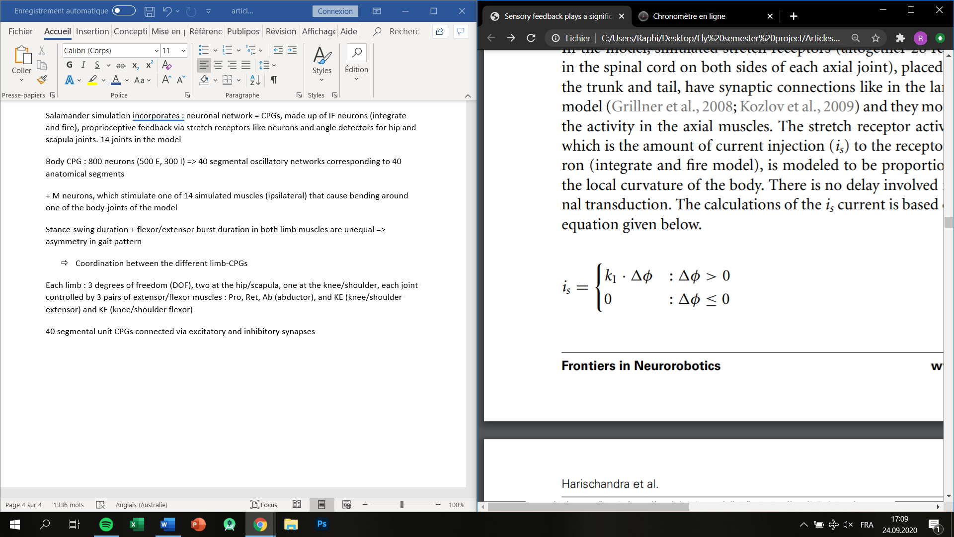Each limb : 3 degrees of freedom (DOF), two at the hip/scapula, one at the knee/shoulder, each joint controlled by 3 pairs of extensor/flexor muscles : Pro, Ret, Ab (abductor), and KE (knee/shoulder extensor) and KF (knee/shoulder flexor)

40 segmental unit CPGs connected via excitatory and inhibitory synapses

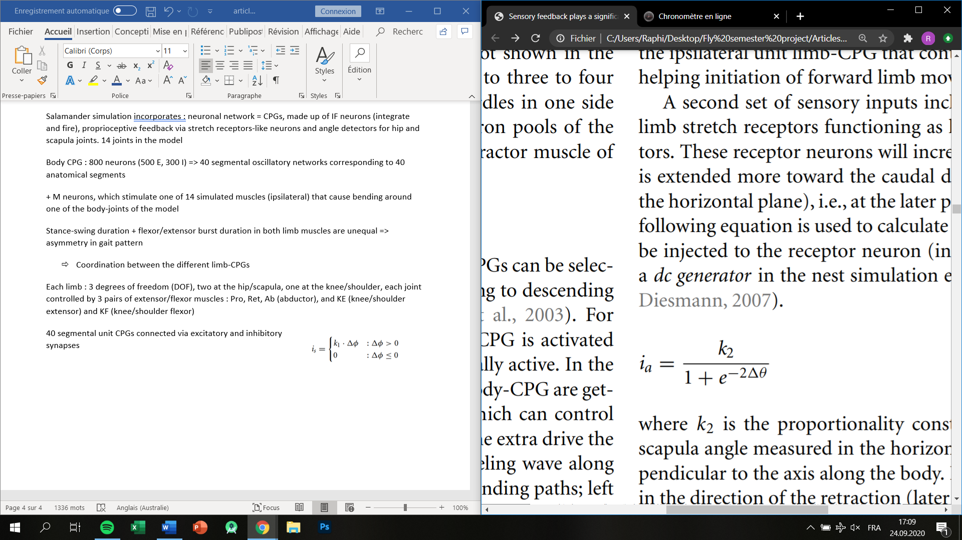i_s : amount of current injection = stretch receptor activation

i_a : required current to be injected to the receptor neuron (hip or scapula angle detector)

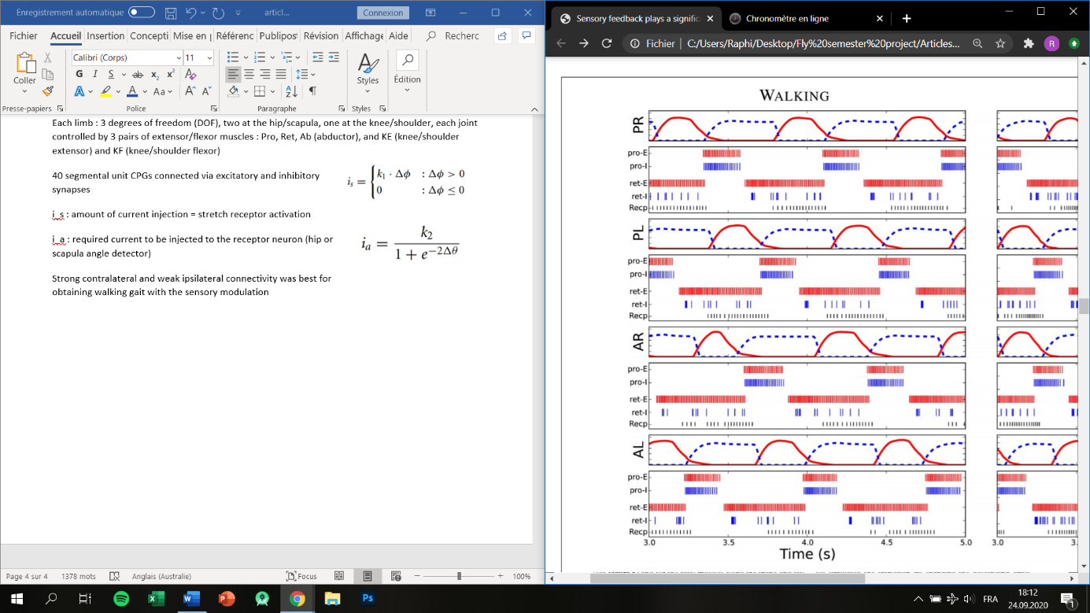Strong contralateral and weak ipsilateral connectivity was best for obtaining walking gait with the sensory modulation

Changing synaptic weight parameter of ipsilateral/contralateral connections during gait transition

*we have hypothesized that the stretch receptors in the limb muscles at the hip or scapula area have a functional role of detecting the extension of the limb in the horizontal plane toward the caudal direction at the later part of the stance phase.*

Hypothesis : same limb-CPGs for walking and trotting gait, but coupled in different ways to generate the different gait patterns

## Enhancing adaptability with local reactive behaviors for hexapod walking robot via sensory feedback integrated CPG

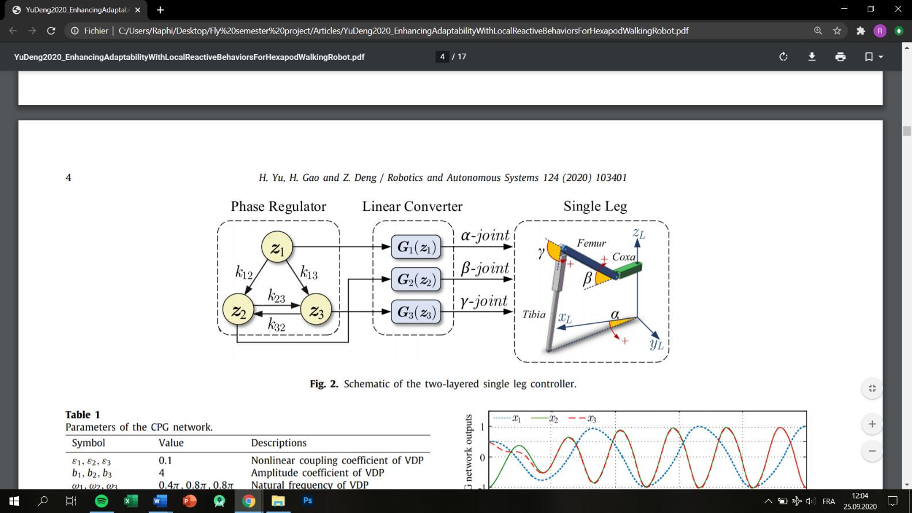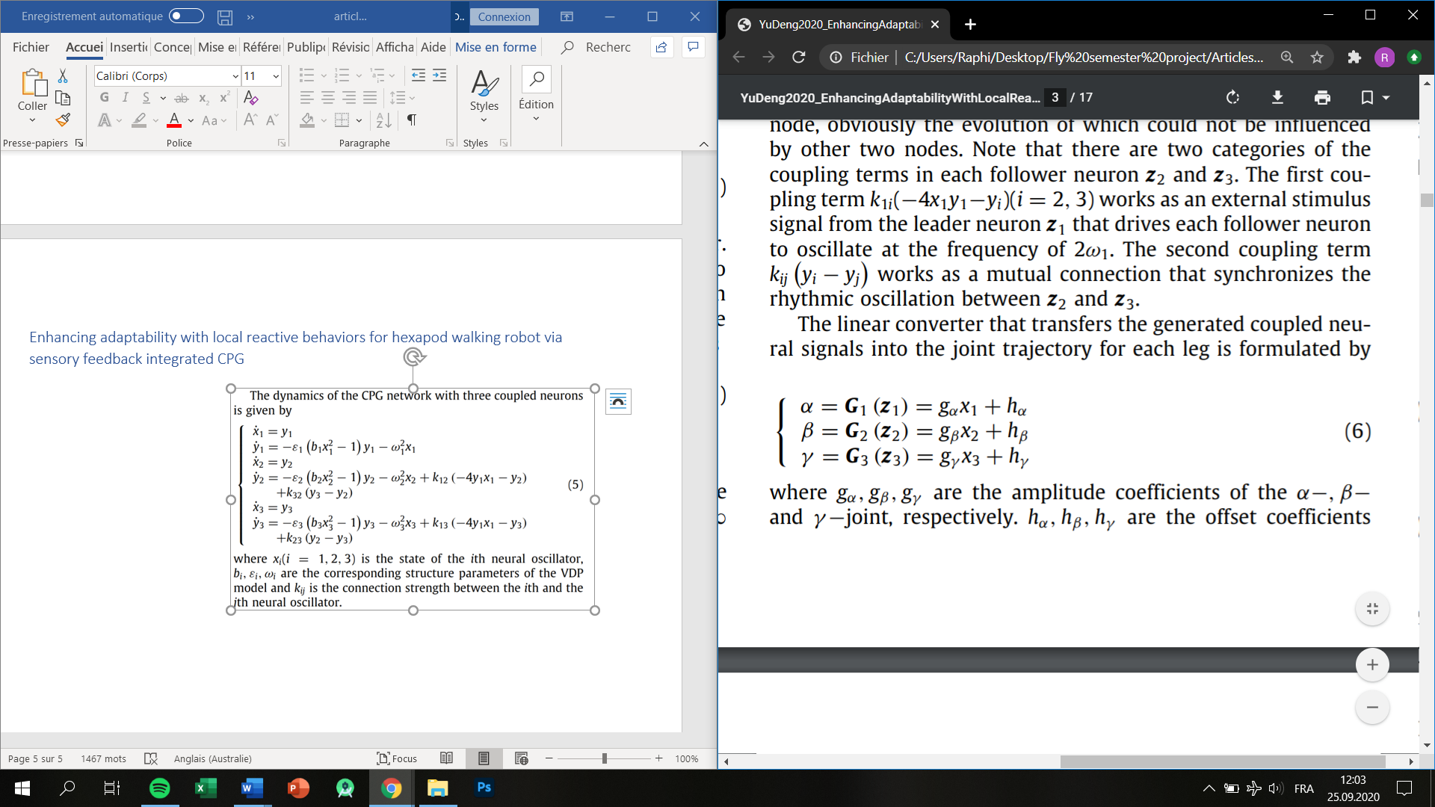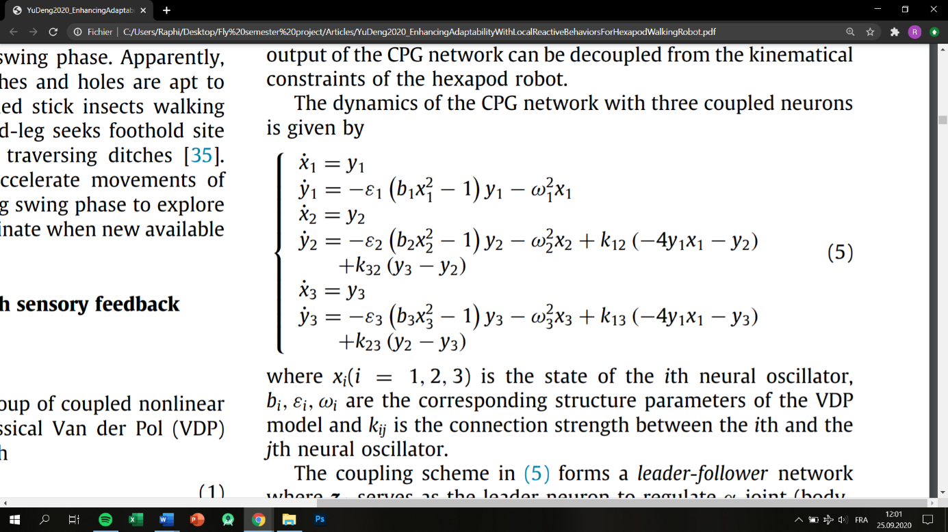3 types of feedback : central feedback, reflex feedback and sensory feedback

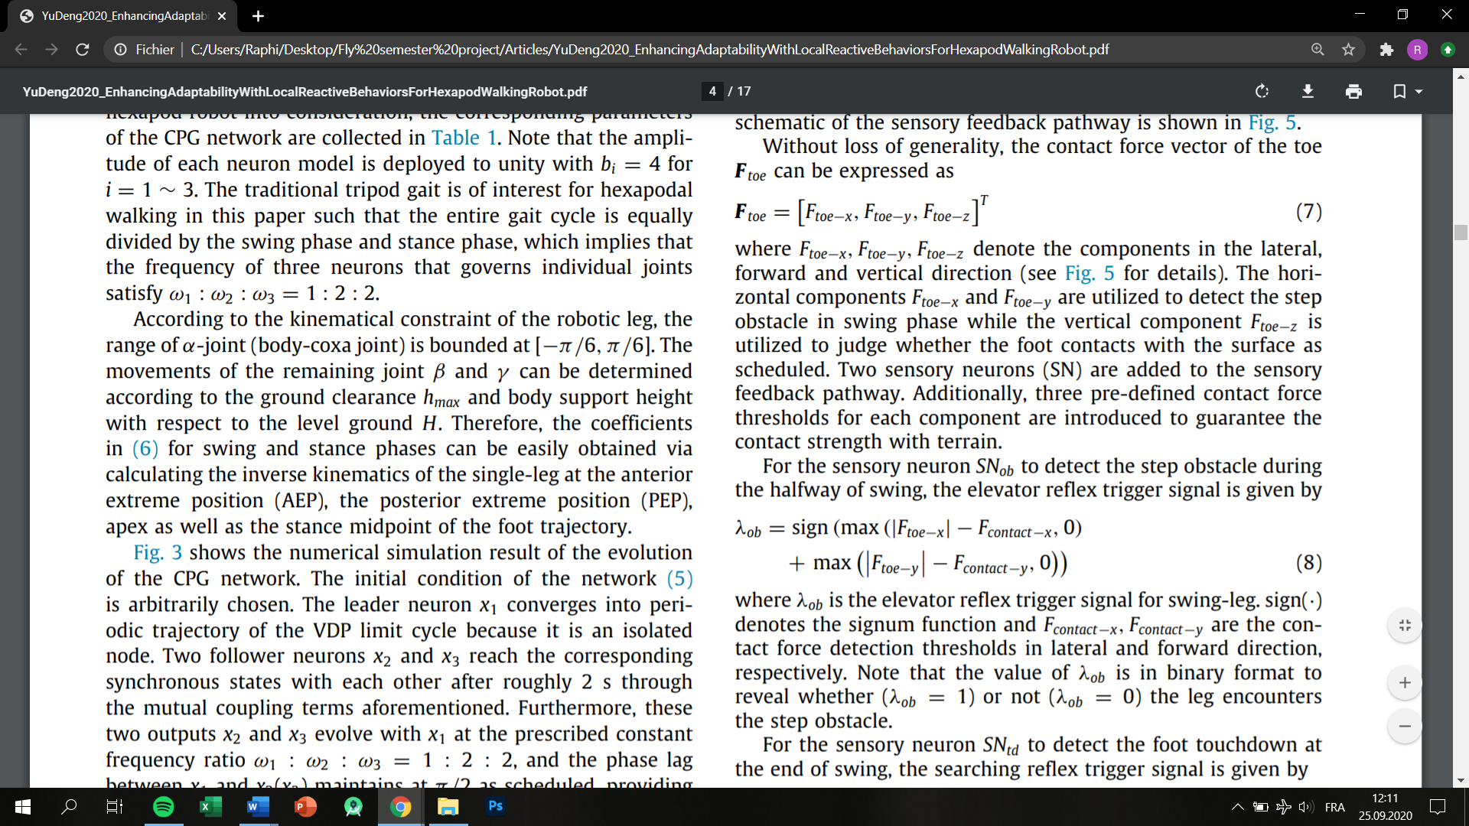Elevator reflex feedback :

Lambda is a binary value that tells if leg encounters an object

Types of reflexes :

* Elevator reflex
* Searching reflex (when there’s a hole)

## Which sensors, what are they capturing, where to put them and why these in particular

Proprioceptive (position or dynamics), torque, or tactile stimulation, muscle load, ground pressure/force

Gait switching is essential (swing to stance transitions)

Proprioceptive feedback from extensor muscles during the stance phase ensures that the leg does not go into swing when loaded and that the magnitude of extensor activity is adequate for support. Proprioceptive feedback from flexor muscles towards the end of the stance phase facilitates the initiation of the swing phase of walking.

Furthermore, our data suggest that feedback from the muscle spindles of the ankle extensor muscles, the triceps surae, is the main source for this mechanism (Mayer, 2018 : <https://journals.physiology.org/doi/pdf/10.1152/jn.00250.2018>)

*Interleg coordination strength seems to be speed-dependent and greater coordination is evident at higher walking speeds.*

*We therefore conclude that the impact of the local sensory signals on the levator–depressor motor system is stronger than the inter-segmental influence through front leg stepping.*

|  |  |
| --- | --- |
| Exteroceptors | Proprioceptors |
| In cats and mice (Akay, 2020) | |
| From outside the body, carried by different types of cutaneous afferents innervating the skin of the body => tactile stimuli  We limit to non-nociceptive cutaneous afferents => only mechanosensitive afferents  When stimulation of dorsal paw during stance => strengthening of ongoing extensor muscle activity  When stimulation during swing phase => activation of distal flexor muscles (elevator reflex)  Cutaneous feedback not necessary for locomotion but important for stability in inclined/declined or ladder   * Cutaneous feedback should be modelled distally, at the end of the limbs | Information regarding posture + movements of the body. 2 main classes of proprioceptive feedback on locomotion :  1) group Ia (dynamic, angular joint movement) and II (static, joint position) afferent fibers that signal muscle stretch  2) group Ib afferents carrying info from the GTOs, GTOs are located at the myotendinous junctions => detection of angular position  Feedback important for (1) strength of muscle activation (mainly Ib), (2) transition from stance to swing  Proprioceptive feedback removal in mice => ataxia, proprioceptive = n°1 priority  Removal of muscle spindles => more susceptible to external perturbations => sensory feedback = stability |
| Walking in insects : how CPGs generate locomotion (Bidaye, 2017) | |
| Sensory organs :  (1) fCO = stretch receptors, similar to muscle spindles (femoral chordotonal organ, Bässler 1983; Hess and Büschges 1999) = movement sensor, detects position, speed, acceleration and vibration of the tibia relative to the femur, located on femur  Both proprioceptors and exteroceptors  (2) CS (campaniform sensilla, Akay et al. 2001, 2004, 2007; Borgmann et al. 2011) = detection of force and load, similar to mammals GTOs = mechanoreceptors, control of posture, grouped in clusters (for ex. in trochanter, proximal femur and proximal tibia) WHICH IS MOST IMPORTANT + WHERE ?, CS thought to reinforce muscle activity during stance phase  Mainly distal, on tarsal segment + some on tibia (location varying from legs to legs)  READ ARTICLE FOR PRECISE DISTRIBUTION (Dinges, 2020)  Initiation + maintenance of stance  See figure with signals corresponding to gait events ! | |
| Interleg coordination : through sensory structures (hair fields and rows, CO and CS)  Subject to behavioural rules : Cru(i)se Control  4 rules  Tibial CS *: Unloading of the hind leg at the transition between stance and swing phase increases load on the ipsilateral middle leg. Tibial campaniform sensilla of the middle leg [62] were shown to specifically sense this rapid increase in load when the hind leg lifts off (Zill 2009, in cockroaches)* | |
| Drosophila neural coding of leg proprioception => fCO 3 populations (Mamiya, 2018) | |
| In Drosophila => fCO can be separated in 3 subclasses encoding for different stimulus features : club, claw and hook, analyze features of femur-tibia joint angle  Club => bidirectional tibia movements + low amplitude vibrations of tibia (during hold), velocity sensitive  Claw => encode for position of tibia relative to femur (both extension and flexion sensed), with each neuron having specific range sensitivity to joint angle, not sensitive to movement  Hook neurons => active during tibia flexion only, no activity during hold period (no reactivity to vibrations), thus directionally selective, encode flexion movements, velocity sensitive  OTHER chordotonal organ : JO (Johnston’s organ), detects antennal movements produced by near-field sound, wind, gravity and touch => monitors rotation of body segment that is not actively controlled by muscles | |
| Sensory feedback role in generating walking (Harischandra, 2011) | |
|  |  |
| Pattern generators equations (Righetti, 2008) | |
| Reset the phase of the oscillators (CPGs) when feet hit the ground (simple model)  Force sensing under foot important role (Frigon, 2006)  Force sensing modulates the onset of swing/stance, if foot hits the ground => switch to stance phase  Correlation between speed of locomotion and stance duration => ωstance = control parameter  Feedback => controller more robust to parameter choice as feedback regulates timing of each phase, thus correcting bad parameters |  |
| Enhancing adaptability in 6-legged robot (Yu, 2020) | |
|  |  |

CRUSE RULES :

* Cruse H. The function of the legs in the free walking stick insect, Carausius morosus. J Comp Physiol 112: 235–262, 1976. doi:10.1007/BF00606541.
* Cruse H. The control of the anterior extreme position of the hindleg of a walking insect, Carausius morosus. Physiol Entomol 4: 121–124, 1979. doi:10.1111/j.1365-3032.1979.tb00186.x.
* Cruse H. Coactivating influences between neighbouring legs in walking insects. J Exp Biol 114: 513–519, 1985.
* Cruse H. What mechanisms coordinate leg movement in walking arthropods? Trends Neurosci 13: 15–21, 1990. doi:10.1016/0166-2236(90)90057-H.
* Cruse H, Dean J, Suilmann M. The contributions of diverse sense organs to the control of leg movement by a walking insect. J Comp Physiol A Neuroethol Sens Neural Behav Physiol 154: 695–705, 1984. doi:10.1007/ BF01350223.
* Cruse H, Dürr V, Schmitz J. Insect walking is based on a decentralized architecture revealing a simple and robust controller. Philos Trans A Math Phys Eng Sci 365: 221–250, 2007. doi:10.1098/rsta.2006.1913.
* Cruse H, Epstein S. Peripheral influences on the movement of the legs in a walking insect Carausius morosus. J Exp Biol 101: 161–170, 1982.
* Cruse H, Kindermann T, Schumm M, Dean J, Schmitz J. WalkNet–a biologically inspired network to control six-legged walking. Neural Netw 11: 1435–1447, 1998. doi:10.1016/S0893-6080(98)00067-7.
* Cruse H, Knauth A. Coupling mechanisms between the contralateral legs of a walking insect Carausius morosus. J Exp Biol 144: 199 –213, 1989.
* Cruse H, Schwarze W. Mechanisms of coupling between the ipsilateral legs of a walking insect Carausius morosus. J Exp Biol 138: 455– 469, 1988.

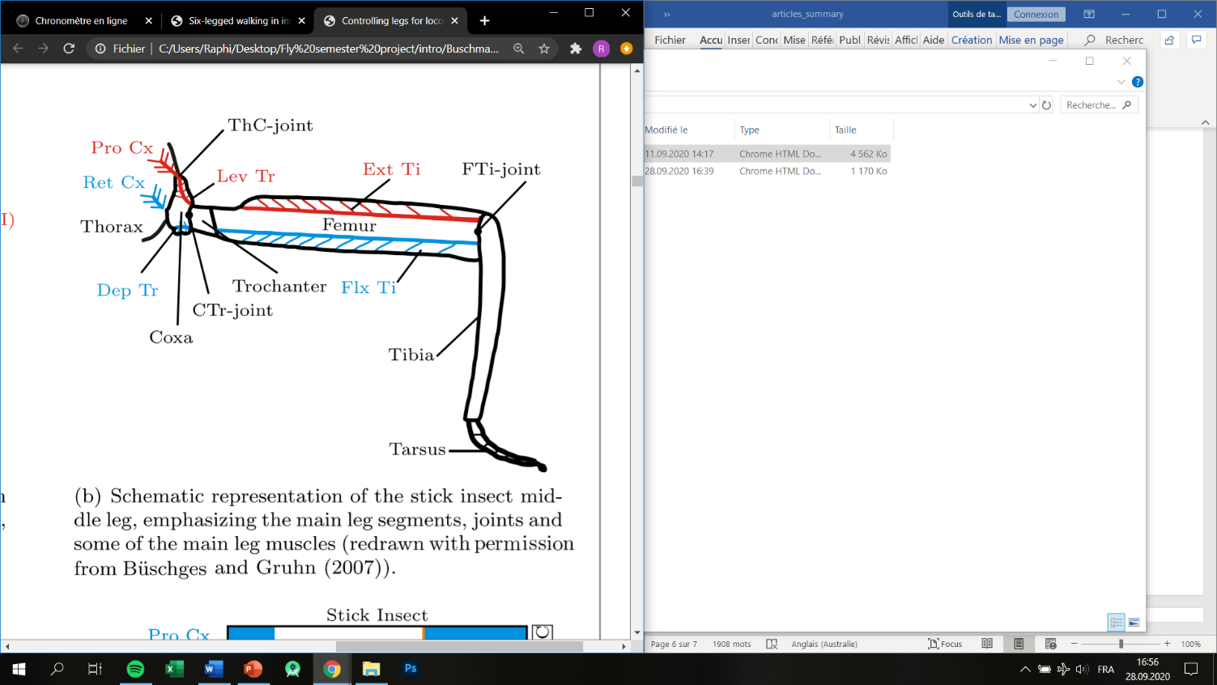

Figure 1 : ThC = thorax-coxa joint, horizontal protraction and retraction movements

CTr = coxa-trochanter joint, vertical levation and depression

FTi = femur-tibia joint, extension and flexion of the tibia

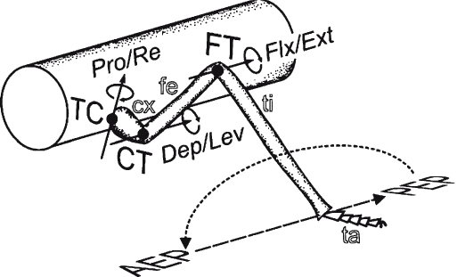

Figure 2 <https://www.google.com/url?sa=i&url=https%3A%2F%2Fwww.researchgate.net%2Ffigure%2FA-schematic-drawing-of-a-leg-of-a-stick-insect-It-consists-of-four-functional-segments_fig2_6690487&psig=AOvVaw10fP9ib3pRbhM6h0Le4Z4n&ust=1602585436803000&source=images&cd=vfe&ved=0CAIQjRxqFwoTCNi-jZTuruwCFQAAAAAdAAAAABAd>

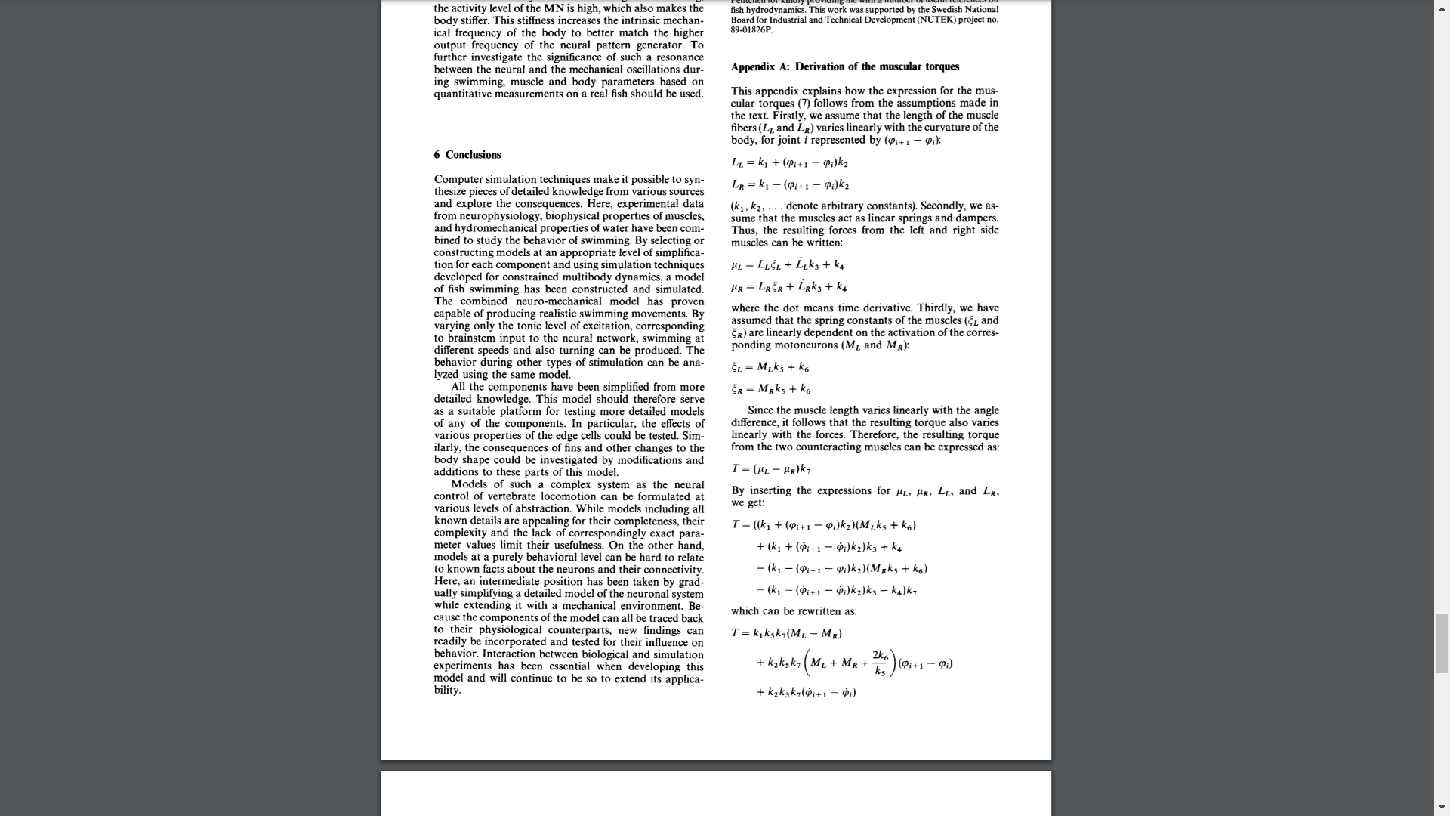

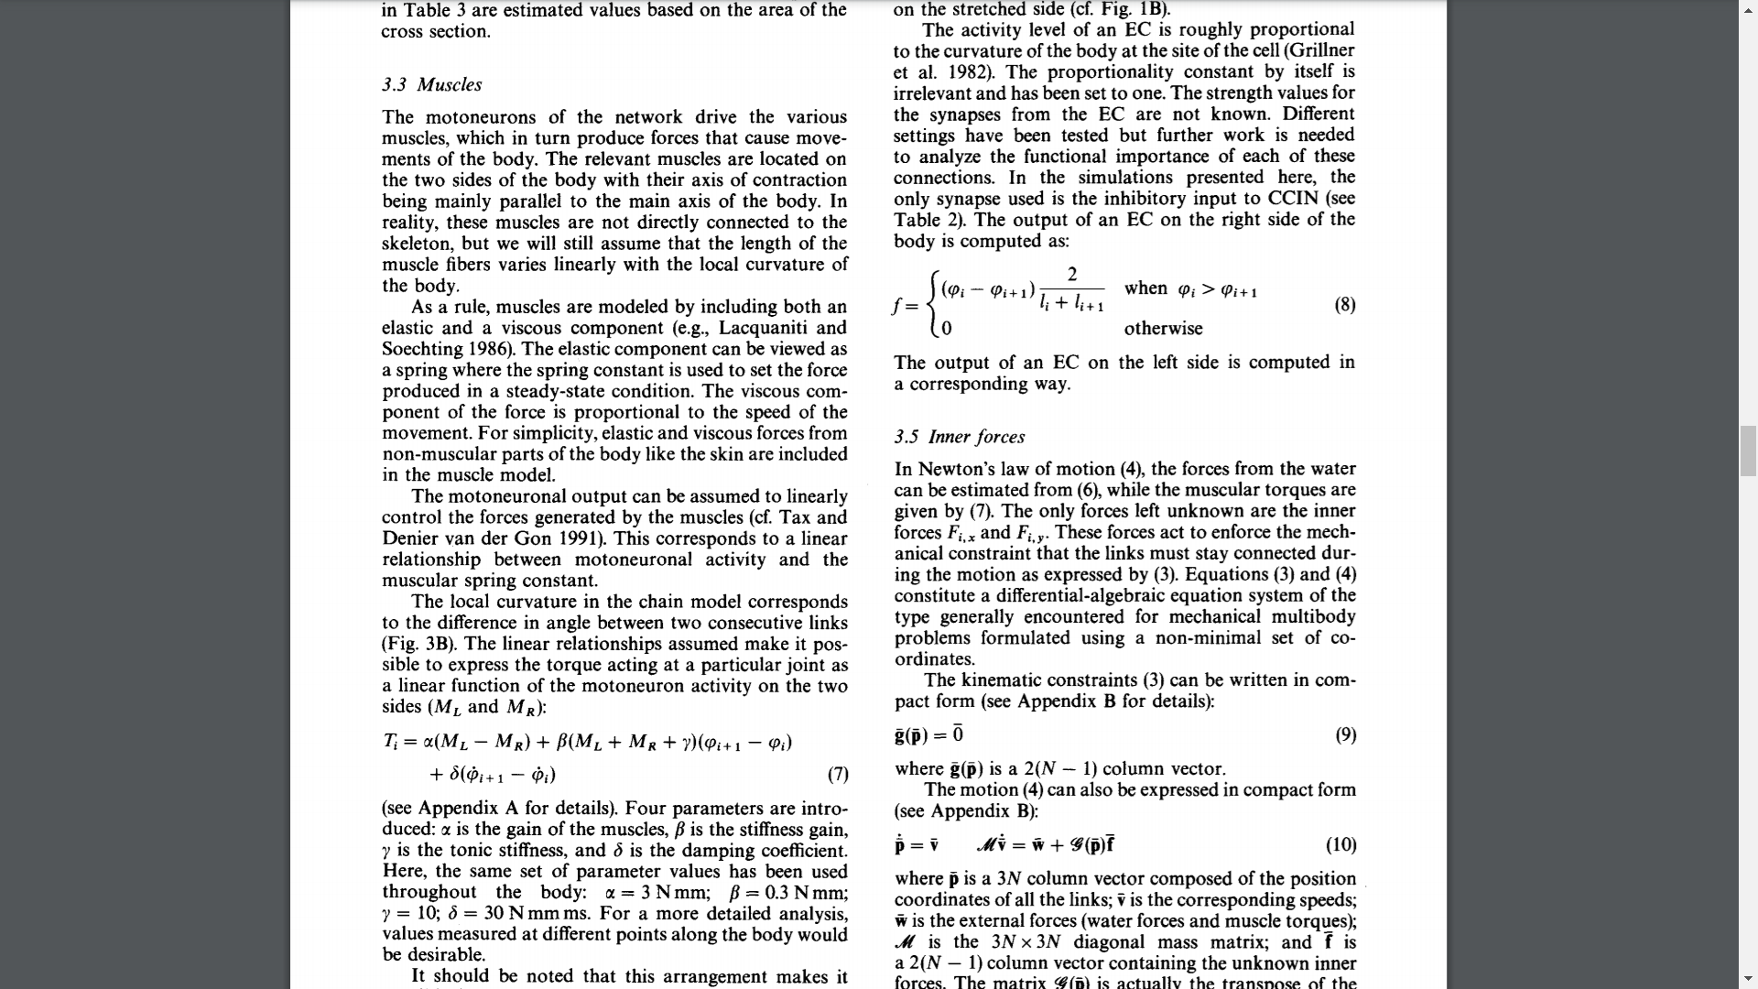

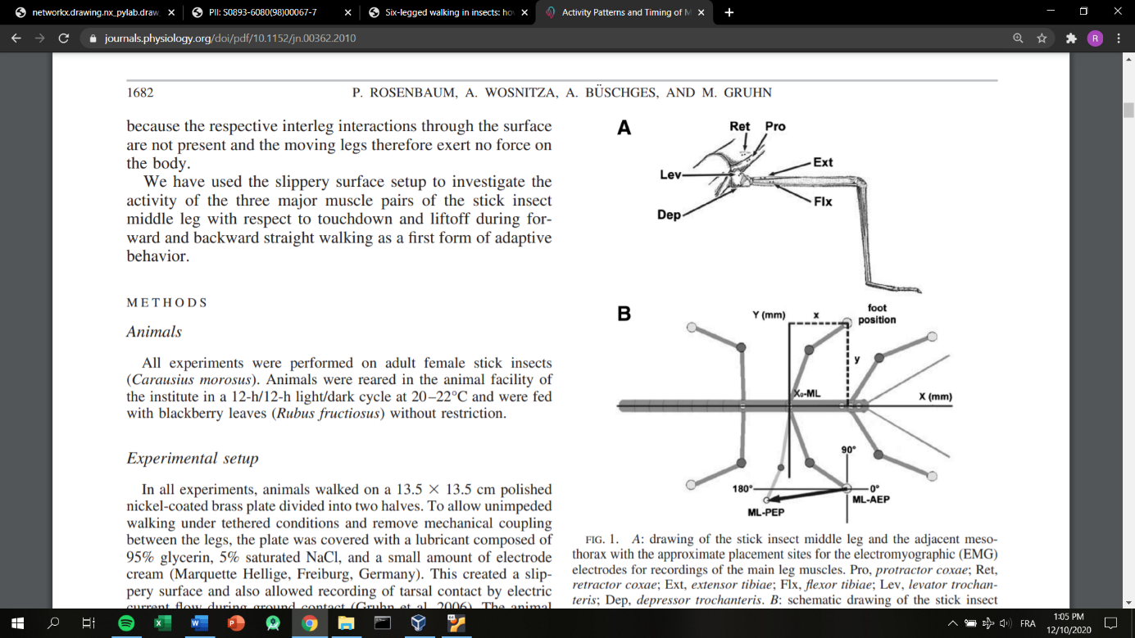

Figure 3 <https://journals.physiology.org/doi/pdf/10.1152/jn.00362.2010>

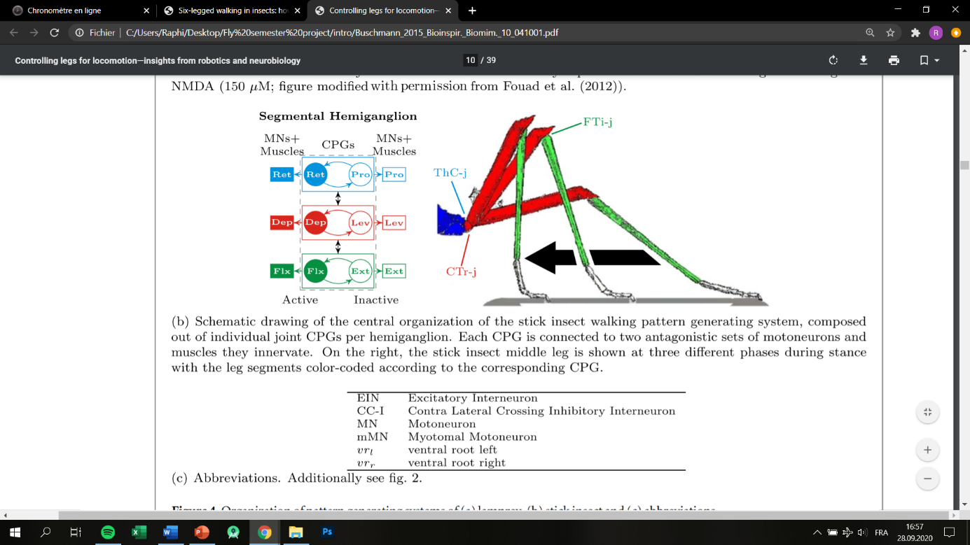

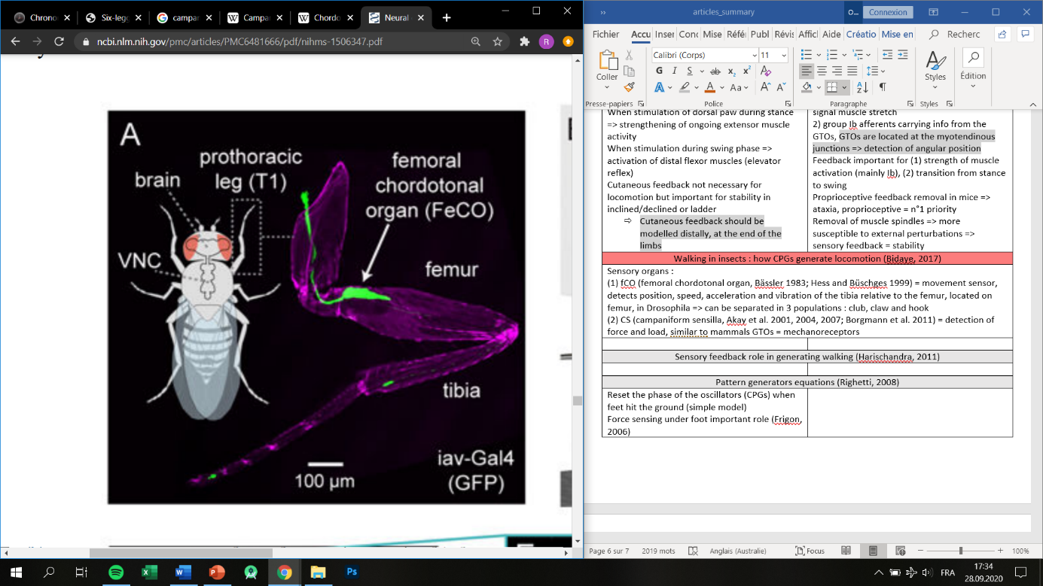

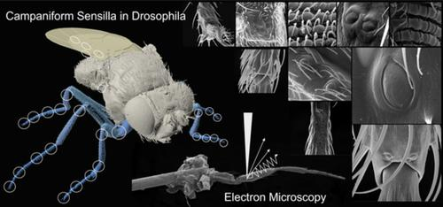

Figure 4: https://www.x-mol.com/paper/1284220495163211776

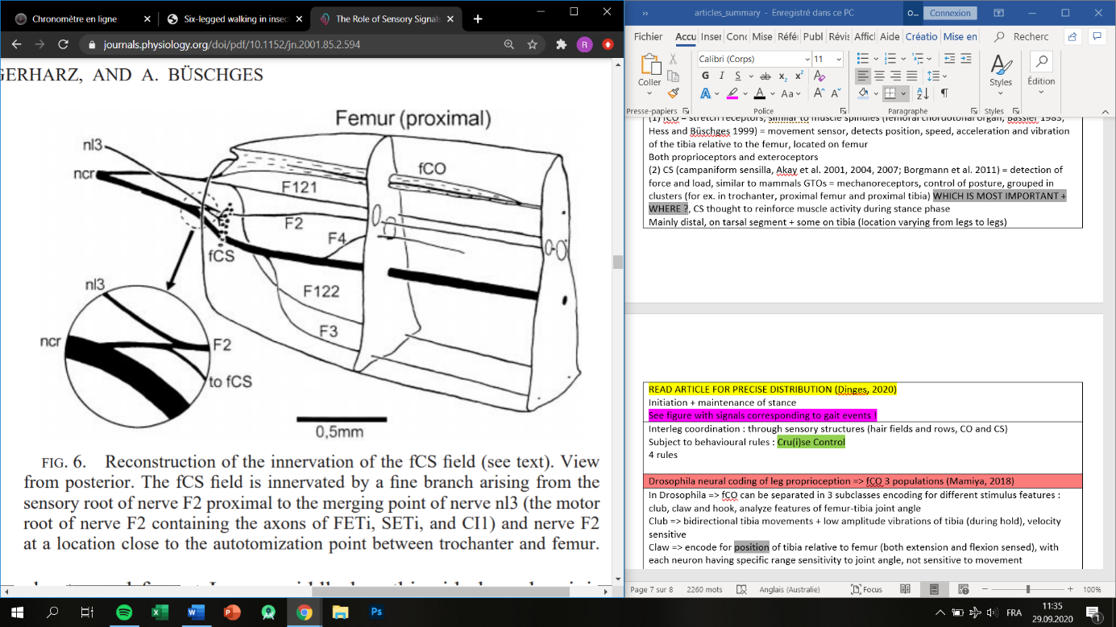

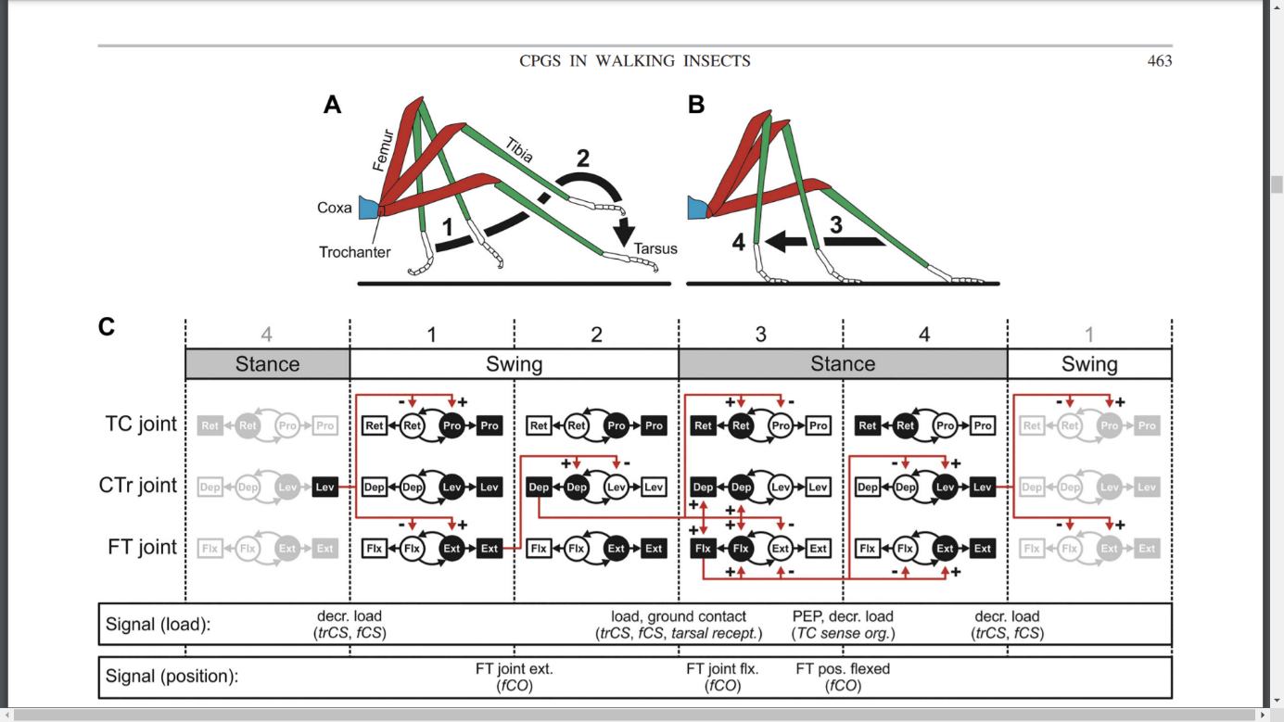

Figure 5 : joints activity + signals from CS and fCO = sensory feedback

WHAT ARTICLE IS THIS BASED ON

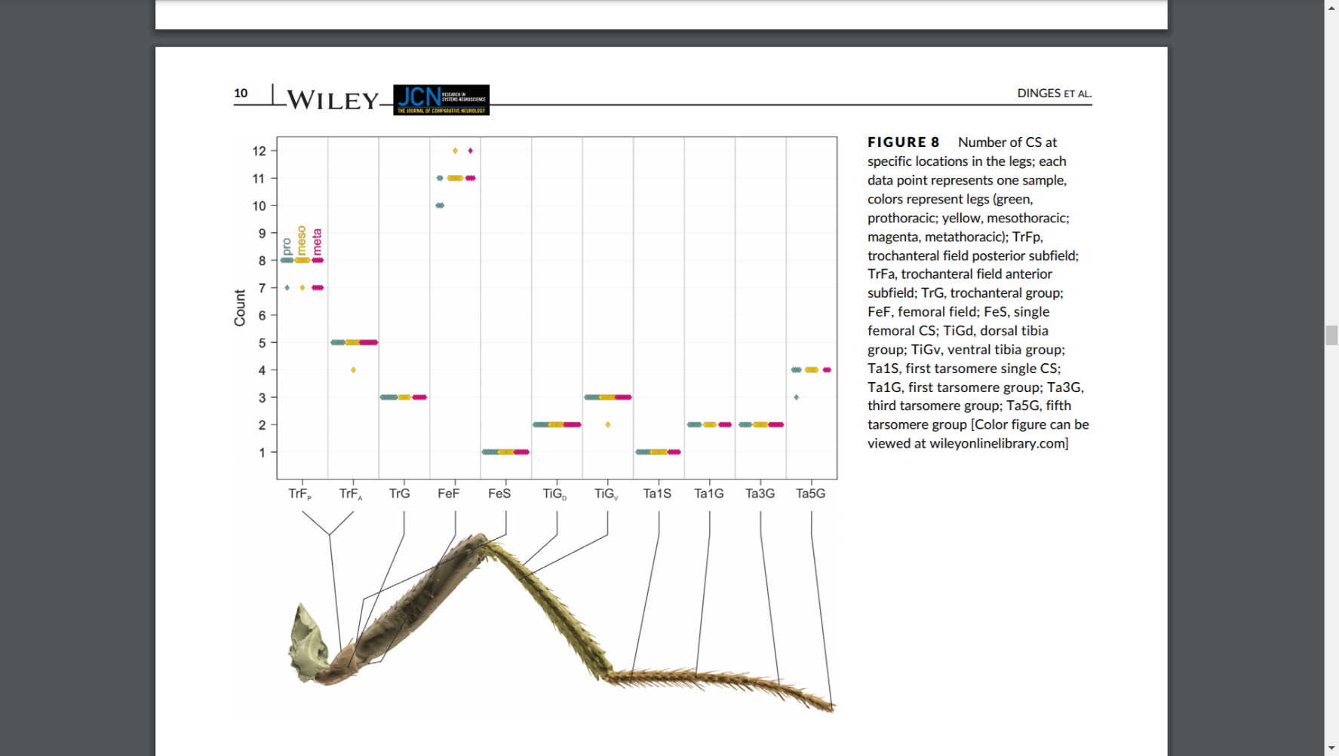

Figure 6 : CS count in groups and depending on the leg => important for concentration of CS

But not important, as we’re just reading the proprioceptive data, their location doesn’t matter

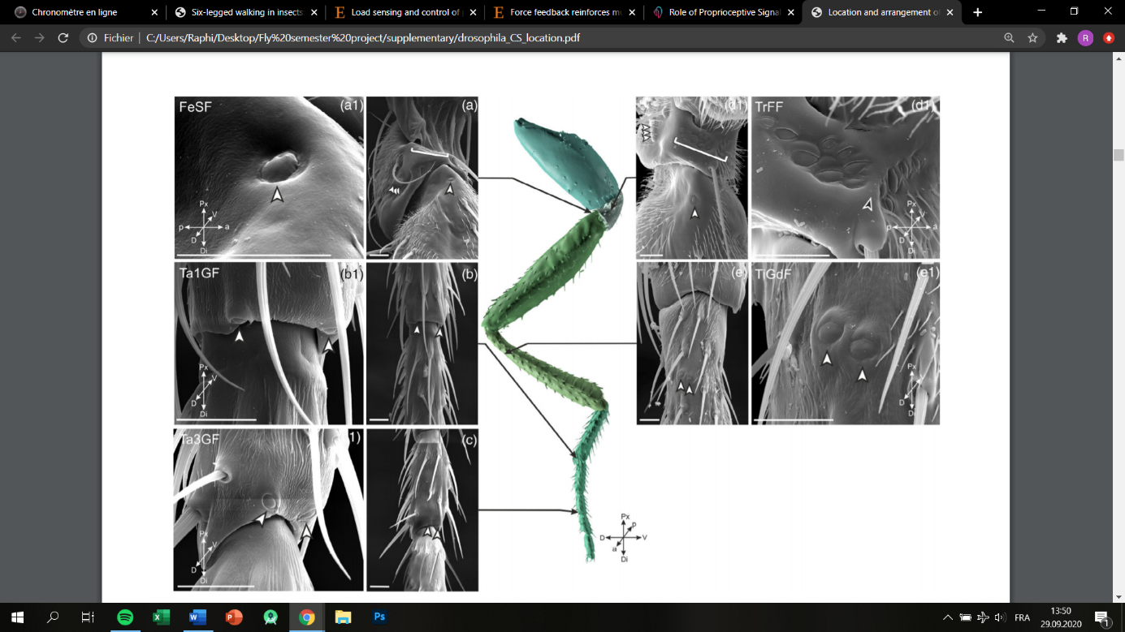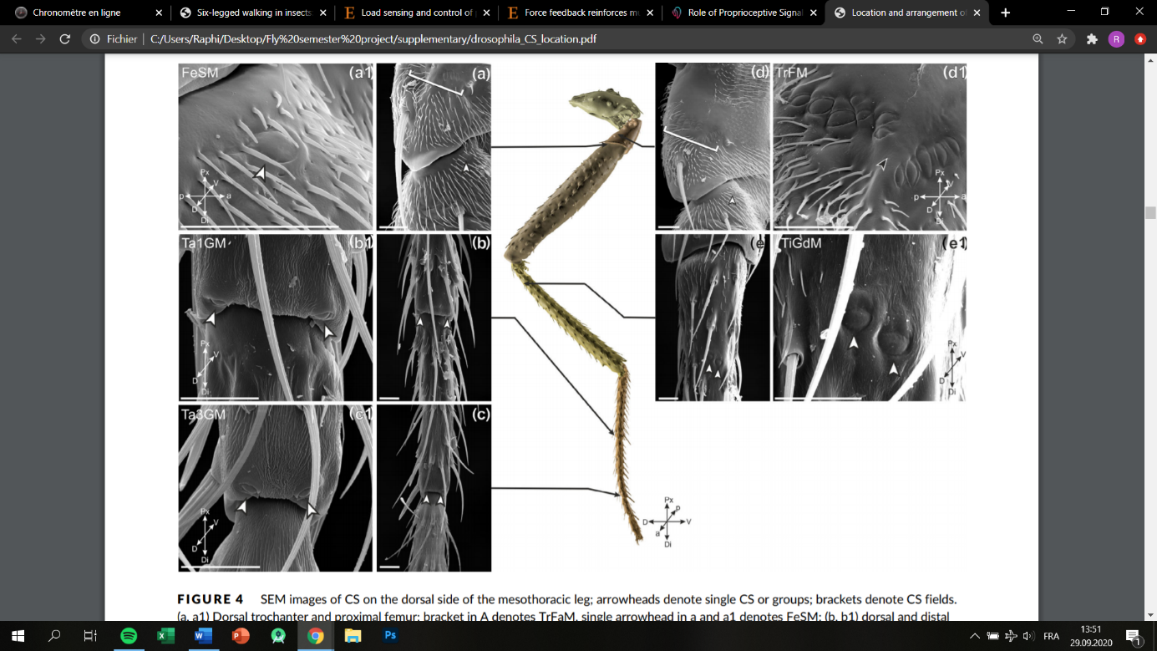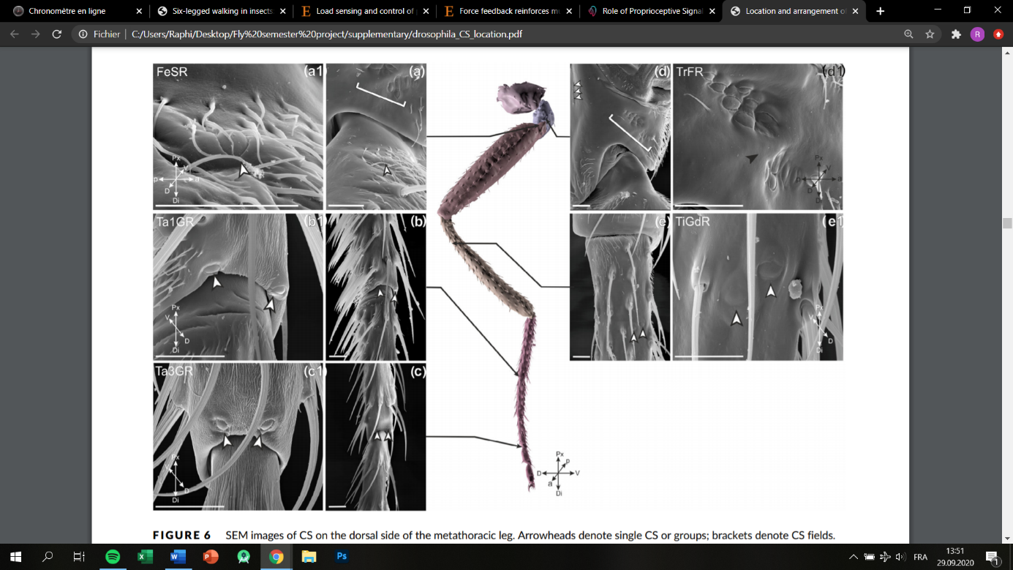

Figure 7 : frontal (left) to hind leg (right) CS location, dorsal side of the leg